COMPARISON

1.Total Sales by Category
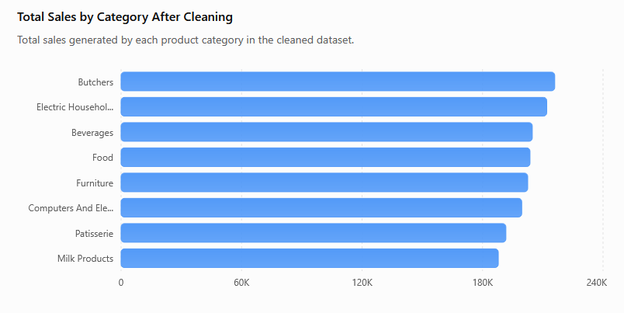
DESCRIPTION:
The chart shows that Butchers has the highest total sales (215,954), while Milk Products has the lowest (187,843.50). This helps identify the strongest and weakest categories in terms of total sales.

2.Transactions by Location
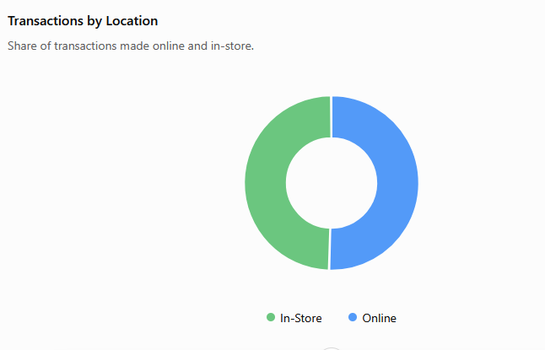
DESCRIPTION:
There are 6,354 online transactions compared with 6,221 in-store transactions. Online transactions are slightly higher, showing that both channels have substantial customer activity.

3. Discount Applied
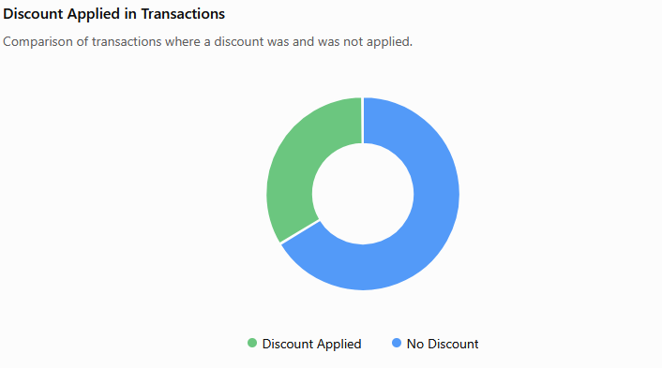
DESCRIPTION:
A discount was applied to 4,219 transactions, while 8,356 transactions had no discount. This shows that most transactions occurred without a discount.

COMPARISON:
BEFORE CLEANING VS AFTER CLEANING

.Missing Values
Comparison: Before cleaning, the dataset contained missing values in several columns. After cleaning, the missing values were filled or corrected, resulting in a complete dataset with 12,575 usable records.
Insight: The cleaning process improved data completeness and made the dataset ready for analysis.

2.DUPLICATE RECORDS
Comparison: The original dataset contained duplicate records, which were identified and removed during cleaning. After cleaning, only unique transaction records were retained.
Insight: Removing duplicates prevents the same transaction from being counted multiple times and improves the accuracy of the analysis.

3. DATA TYPES
Comparison: Before cleaning, some columns contained inconsistent or incorrect data formats. After cleaning, numerical, categorical, date, and other fields were converted into appropriate and consistent formats.
Insight: Standardized data types make calculations, grouping, and visualization more reliable.

4. INCONSISTENT VALUES
Comparison: The original dataset contained inconsistent entries and formatting issues. These values were standardized or corrected during cleaning, producing a more consistent dataset for analysis.
Insight: Data standardization reduces errors and ensures that similar values are treated as the same category.

5. DATASET SIZE
Comparison: The dataset initially contained 12,575 records and 11 columns. After the cleaning process, the dataset was retained in a structured form with 12,575 records and 11 columns.
Insight: The cleaning process preserved the required transaction data while improving its quality and consistency.

6. OVERALL DATA QUALITY
Comparison: The before-cleaning dataset contained missing, duplicate, and inconsistent data, whereas the after-cleaning dataset contained standardized and analysis-ready values.
Insight: Cleaning transformed the raw retail sales data into a more reliable dataset suitable for sales, category, payment, and customer-behavior analysis.

